VOLUNTEER JUDGE GUIDE
RESOLVED:
The United States federal government should substantially increase fiscal redistribution in the United States by adopting a federal jobs guarantee, expanding Social Security, and/or providing a basic income.

INTRODUCTION TO POLICY DEBATE

Policy debate is a competitive academic activity in which two teams of debaters argue for or against a change in U.S. federal policy. In policy debate, the quality of the argument is more important than the style or rhetoric, and the team with better arguments and reasoning should prevail.
The Resolution & Cases
Policy debate starts with a resolution, a statement that a specific change should be made to U.S. federal policy to address a national or international problem. The resolution is the “topic” of the debate, and is the same for all policy debaters for each academic year. Cases are sub-topics that focus the debate on a specific policy, and vary by league and team. PUDL has specific restrictions of what cases are allowed at each level of debate.
- Novice
  - Affirmative case: Pass the Green New Deal (which includes a federal job guarantee)
  - Negative: IRS Disadvantage
- Junior Varsity
  - Affirmative cases
    - Basic Income: Universal Basic Income
    - Basic Income: Basic Income for Persons at or near the Poverty Level
    - Federal Jobs Guarantee: Green New Deal
    - Social Security: Medicare for All
  - Negative: anything goes!
- Varsity
  - Anything goes!

The Teams & Room Setup
Each team is made up of two debaters. (Occasionally, a team will have only one team member, called a maverick. Mavericks play both roles for their team.) One team, the Affirmative must propose a plan to change federal policy, and argues in favor of the plan. The Negative team must argue against the Affirmative’s plan. Note that the Negative is arguing against the plan, not necessarily the resolution itself. Debaters alternate sides during a tournament.
Teams usually sit on opposite sides of the room, both facing the judge. To help you keep track of debaters’ speaking orders, you may encourage debaters to sit in order of their speaking positions, as pictured below. Speakers can be referred to by their side and speaking order, as in 1A for the first affirmative speaker, 1N for the first negative speaker, and so on.

1st Negative
Debater
1N
2nd Affirmative
Debater
2A

1st Affirmative
Debater
1A
2nd Negative
Debater
2N

Judge

The Speeches
Each debater makes two speeches: a constructive, and a rebuttal. In the first speech, called a constructive, a debater lays out the basics of their arguments and reads supporting evidence. Each constructive speech is followed by a period of cross-examination, or cross-ex, in which the debater who just spoke may be questioned by their opponent (usually by the team member who is not about to speak). In their second speech, called a rebuttal, each debater responds to arguments from their opponents and explains why the judge should vote for their team. There is no cross-ex after rebuttals.
Teams alternate turns within the round, with the Affirmative giving the first constructive and final rebuttal, and the Negative giving the final constructive and the first rebuttal. that means the Affirmative speaks first and last, and the Negative speaks two times in a row in the middle of the round. Each speech is timed, with slightly different timing at the novice and varsity levels. See the Speech Order Guide (page 3) for the specific order and timing of each speech.

YOUR ROLE AS A JUDGE

Judges have important responsibilities within each tournament and round. Judges must listen to each debate round, determine a winner, share feedback, and complete and return a written ballot. The rest of this guide will explain how to complete each of these responsibilities.
In addition to these specific responsibilities, judges have an important role as leader in the debate space. They play a crucial role in ensuring that each round and tournament is a positive experience and rich learning opportunity for students. Throughout their service, we ask that judges model respectful and inclusive behavior at all times, engage and support students as they progress through the debate round, and uphold our values: power of young people, analytic discourse, diversity and inclusion, racial and social equity, and joy in learning.
Best Practices for Judges
Judging is a skill that takes time to develop. With time, all judges develop philosophies and preferences that guide their decisions and evaluation of each round. As you begin or continue your judging career, please keep the following best practices in mind:
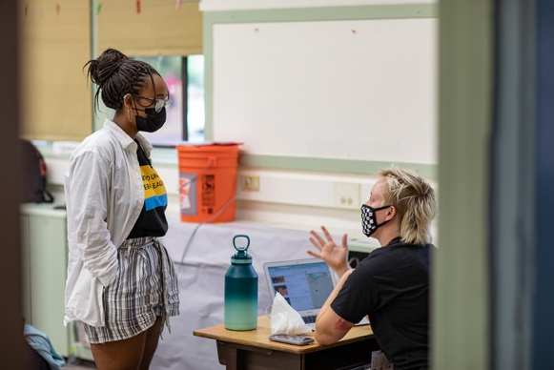
- Be objective. To judge effectively you must be open-minded to arguments, even if they conflict with your personal beliefs or outside knowledge. Be aware of your own knowledge, opinions, and biases as they relate to the topic, and do your best to avoid determining winners based on their alignment with your viewpoints. Let the arguments persuade you!
- Be open-minded. Effective judges must also remain open to ideas and arguments that are new, unexpected, or even controversial. This openness is part of what makes debate a safe space for grappling with new, complex, and exciting ideas that aren’t usually part of classroom learning.
- Be conscientious. Debate is and should be an activity where students feel that they are important, that their opinions matter, and that judges care about them and their growth. Please give your full attention, celebrate students’ work, and share constructive feedback to the best of your ability.
- Be yourself! Students benefit from the variety of experiences that our judges bring to each tournament. We do not expect all judges to be exactly the same, or even vote the same way. We ask you to do your best, as debate events are a learning opportunity for everyone.

SPEECH ORDER GUIDE

All speeches in policy debate are timed. In addition to speeches, each team has either 5 minutes of total prep time. Debaters may use prep time to review evidence, take notes, or confer with their partner. Prep time may be used before any speech, and does not count towards the allotted time for any speech.
Speech |  | Purpose | Novice | JV/Varsity
1AC | 1st Affirmative Constructive | Introduce the problem, the Affirmative’s plan to fix the problem, and reasons why the plan will work. | 6 | 8
Cross-Examination |  | 2N questions 1A | 3 | 3
1NC | 1st Negative Constructive | Introduce arguments against the problem or the Affirmative’s plan. | 6 | 8
Cross-Examination |  | 1A questions 1N | 3 | 3
2AC | 2nd Affirmative Constructive | Respond to arguments made in the 1NC. “Extend” (bring back up), expand on, and/or refine arguments from the 1AC. Introduce any final new arguments in favor of the plan. | 6 | 8
Cross-Examination |  | 1N questions 2A | 3 | 3
2NC | 2nd Negative Constructive | Extend, expand on, and/or refine arguments made in the 1NC. Introduce any final new arguments against the plan. | 6 | 8
Cross-Examination |  | 2A questions 2N | 3 | 3
1NR | 1st Negative Rebuttal | Continue to extend, expand on, and/or refine arguments made in the 1NC or 2NC. | 4 | 5
1AR | 1st Affirmative Rebuttal | Respond to the 2NC and 1NR. Remind the judge of arguments made in the 1AC and 2AC. | 4 | 5
2NR | 2nd Negative Rebuttal | Summarize the Negative arguments and explain why the Negative should win. | 4 | 5
2AR | 2nd Affirmative Rebuttal | Summarize the Affirmative arguments and explain why the Affirmative should win. | 4 | 5
Prep Time |  | Coordinate, plan, and research. | 5 – per team | 5 – per team
COMMON HABITS & PRACTICES IN DEBATE

Organization in Speeches
Effective debaters use specific techniques to help everyone in a round stay organized and follow the arguments being made. Debaters should take a moment before each speech to give a roadmap, or a list of the arguments that they plan to address during the speech and the order in which they plan to address them. Time spent giving a roadmap is free time and should not be counted against the team.
During the speech, debaters typically give a one-sentence summary of each argument before addressing it. This is called a tagline. Taglines are part of speeches and should be included in a speaker’s time. Stronger debaters find ways to emphasize their taglines, often by slowing down or changing their tone.
Common Habits in New Debaters
Newer debaters are still developing presentation skills and confidence. They might not make eye contact or project their voices effectively, and they might pause or stumble more frequently. This is all part of the learning process, and there’s no need to comment on it. Nervousness is natural, and you can help make debaters feel comfortable by introducing yourself, smiling, and letting them know how excited you are to be judging their round.
Debaters with less experience might also be uncertain about whose turn it is, and they might not use all of their cross-ex, prep, or speech time. You can use your speech order guide to help remind them of whose turn it is, and you should always encourage debaters to keep going when they seem like they might want to give up. You may pause time to do this if it feels appropriate.

Common Habits in Experienced Debaters
A Note for Varsity Judges
We encourage debaters to bring their full selves to debate, and support them in trying new and creative forms of argumentation and expression within the format of policy debate. Please keep an open mind toward ideas or presentation formats (such as poetry or song) that might be outside of your personal experience or what is traditionally considered to be part of policy debate. If you have any questions or concerns about a particular round, please feel free to speak with a PUDL staff member.
More experienced debaters are known for speaking quickly and with a unique cadence. If this interferes with your ability to understand the round, don’t be afraid to ask debaters to slow down or speak up if necessary. Experienced debaters may also use debate-specific terminology: if you’re not familiar with the language, focus on the arguments and/or use the glossary on page 13.

Experienced debaters usually have a lot more to say than newer debaters, and may run out of time. It’s common courtesy to allow debaters to finish their sentence when the timer goes off. Higher-level debaters may be more competitive, and on very rare occasions this can lead to unsportsmanlike behavior. If this happens in your round, you can remind debaters to speak or behave respectfully. If it continues, you may bring the issue up in feedback, lower the debater’s speaker points, or pause the round to speak with tournament staff. If you lower speaker points or bring up the issue in feedback, please let a tournament staff member know after the round.
Encouraging & Supporting Debaters
Debate is and should be a safe space for learning, but safe doesn’t always mean comfortable. As a judge, you should push and encourage debaters even when they look like they’re struggling, nervous, or overwhelmed, and celebrate their hard work and growth at the end of the round.
DETERMINING A WINNER

Determining a winner is one of a judge’s most important responsibilities. In choosing a winner, we ask that all judges:
- Wait until the round is complete and all debaters have spoken before making a decision.
- Take notes to help you track and evaluate the arguments, and review them before making a decision.
- Remember that there is no correct answer! Debate is about persuasion, and only you can determine which team persuaded you.
What to Consider
Always prioritize substance over style. Choose the team that presented the strongest arguments and responded best to their opponent’s arguments. Focus on the major issues in the round, and look for arguments that make sense and are supported by reasoning and evidence. When both teams have good points, try to weigh the arguments against each other.
What Not to Consider
Above all, avoid basing your decision on your personal opinion, debaters’ presentation skills or appearance. Decisions should never be made based on pronunciation, accent, or reading fluency.
All arguments should be introduced in early speeches and fully explained by the end of the round. You can disregard any points made during cross-ex that weren’t reiterated in a constructive or rebuttal, as well as any minor points and arguments that don’t make it to the final speeches or that are introduced during rebuttals. Arguments that are not discussed in rebuttals are generally considered dropped, or conceded.
When to Vote Aff, When to Vote Neg
The burden of proof lies with the Affirmative. In other words, the Affirmative must prove that enacting their plan is better than taking no action. The Negative must only prove that the plan is not a good idea.
You should vote for the Affirmative if they have convinced you that:
- An urgent, significant problem exists in the world today
- The plan presented by the Affirmative can solve the problem, and
- Fixing the problem will make the world a better place
You should vote for the Negative if they have convinced you that:
- The problem identified by the Affirmative isn’t urgent or significant
- The proposed plan won’t work as intended, or
- The harmful costs of implementing the affirmative plan are more significant than any benefits
Still having a hard time deciding? Look for the Tournament Director or a fellow judge to talk through your decision. Once you make a decision, please do not disclose the winner to the students.

WRITING A REASON FOR DECISION (RFD)

The purpose of a Reason for Decision (RFD) is to explain why each team won or lost. The RFD should focus on the arguments and evidence that were presented in the round. This helps ensure that the judge’s decision is based on argumentation, rather than style, and helps promote academic rigor in the league.
- Strong RFDs discuss the impacts of the affirmative and negative arguments, including why certain impacts were proven to outweigh other impacts in the round. Strong RFDs also discuss the plan or advocacy, and whether or not enacting the plan makes the world a better place.
- Weak RFDs discuss superficial elements, like presentation and clarity. (Remember that strong presentation skills and clarity can be recognized through speaker points.) Weak RFDs are usually unclear, nonspecific, and/or unrelated to the content of arguments.

Example Strong RFD: Voted for Affirmative Team
The affirmative team won this debate because they established that human rights violations are occurring due to deportations, they proved that deportations are increasing despite plans to decrease deportations, and they proved that their plan will reduce deportations, thus reducing human rights violations.
The negative team made some strong arguments about the economic impacts of deporting immigrants and proved that the economic impacts that immigrants have in this country may be minimal. However, in my mind, the affirmative team proved that the positive impacts that ending deportations would have on human rights outweighed the negative economic impacts that would result from ending the deportations.
Example Weak RFD: Voted for Affirmative Team
I voted for the affirmative team because they sounded great and had good explanation. I think they really knew their argument. They gave good eye contact and could answer all the questions in cross-ex.
Example Strong RFD: Voted for Negative Team
The negative team won this debate because they were able to prove that the human rights violations discussed by the affirmative team would not be solved as a result of enacting the plan for two reasons:
- States will continue to exclude immigrants in many ways, even if deportation reform occurs. Human rights violations will still exist even if we end surveillance intended for deportations.
- Current policies already in place are already solving for those human rights violations. Since ICE is already reforming, there is no need for the plan. Although deportations have not decreased yet, the negative team proved that current policies will soon address human rights violations.
The affirmative team couldn’t prove that positive economic impacts would result from reducing deportations by reducing surveillance. Since the affirmative team couldn’t prove that their plan would result in a better state for either the economy or the human rights of immigrants, their two main harms, I have to vote for the negative team.
Example Weak RFD: Voted for Negative Team
I voted for the negative team because I liked their argument about the economy. They spoke clearly and presented their argument well. They asked great questions in cross-ex which stumped the other team.

EVALUATING THE SPEAKERS

Speaker points and speaker rank are an evaluation of debaters’ individual arguments and presentation skills during a round. They are used together to calculate the top speakers in each tournament.
Speaker Points
Speaker rank is a comparison of speakers within the round, and is used to determine the best speakers at the tournament and break ties when teams have the same win/loss record. Speaker rank ranges from 25-30 with the best speaker in the round ranking higher than the other speakers. Ties are allowed!
25- Needs a lot of improvement
26- Decent, but still struggling to fill speech time or make cohesive arguments
27- Average!
28- Better than average, made cohesive and insightful arguments
29- Impressed you, you think this student is the best debater at the tournament
30- WOW this is the best debater you’ve ever seen.
Low-Point Wins
Occasionally, a team will win a debate, but receive fewer overall speaking points. This happens when a team has stronger argumentation skills than their opponent, but weaker presentation skills. This is called a low-point win.

GIVING VERBAL FEEDBACK

The purpose of verbal feedback is for debaters to learn a few key ideas that they can immediately apply to their debate rounds for the rest of the day. Aim to give one complement and one suggestion to each debater. Feedback should be both positive and constructive, telling debaters what they did well in the round and what they can improve. Feedback should be as specific as possible and should focus on the content of the arguments.
When giving feedback, please do not make comments about debaters’ physical appearance, culture, reading ability, or accent. We also suggest avoiding feedback on pronunciations, except for key terms related to debate or the topic.
Examples of Strong, Celebratory Feedback
- I found your argument about ____________ persuasive because…
- You did a good job in cross-ex by (clarifying / illustrating deficiencies / entrapping opponents).
- Your cross-ex answers supported your arguments well by…
- You did a good job extending your team’s argument about _____________ in your (speech)
- I thought your argument about _____________ showed great analysis because…
- Your answers in the (name of speech) were well-organized and numbered.
- Your cross-ex after the (name of speech) did a great job of clarifying some difficult points.
Examples of Strong, Constructive Feedback
- I didn’t understand your argument about ___.
- You could have done ________________ to improve your organization and clarity in the round.
- Try to fully explain the impacts to your arguments in order to answer the question “why is the plan a good/bad idea?”
- Try to help guide the judge’s decision making by explaining why (I) should vote for your team. This explanation should include a comparison of arguments in the round, reasons why you believe you won those arguments, and why they were the most important arguments in the round.
- You could improve your (clarity) (organization) (presentation) by ___
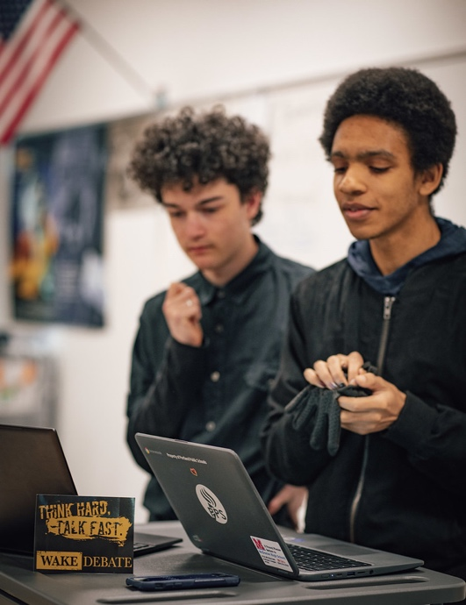
Examples of Incomplete or Hurtful Feedback
These examples could be helpful in combination
with additional comments that are directly related to the arguments.
- Be louder.
- Good eye contact.
- You were clear.
- You were very convincing.
- Great speech.
These examples are not constructive and
should be avoided:
- Don't stutter.
- Try to improve your accent/pronunciation.
- Your argument was too ___.

BALLOTS
A ballot is a written record that shows who won the round and why, and contains feedback from a judge to show how they came to that decision. Ballots help debaters and coaches understand why they won or lost, and what they can do to improve. Ballots will be shared with debaters and coaches, so please be respectful.

I have never used Tabroom.com to submit online ballots. It’s no problem! This is true for many judges.

The steps to submit online ballots are simple:

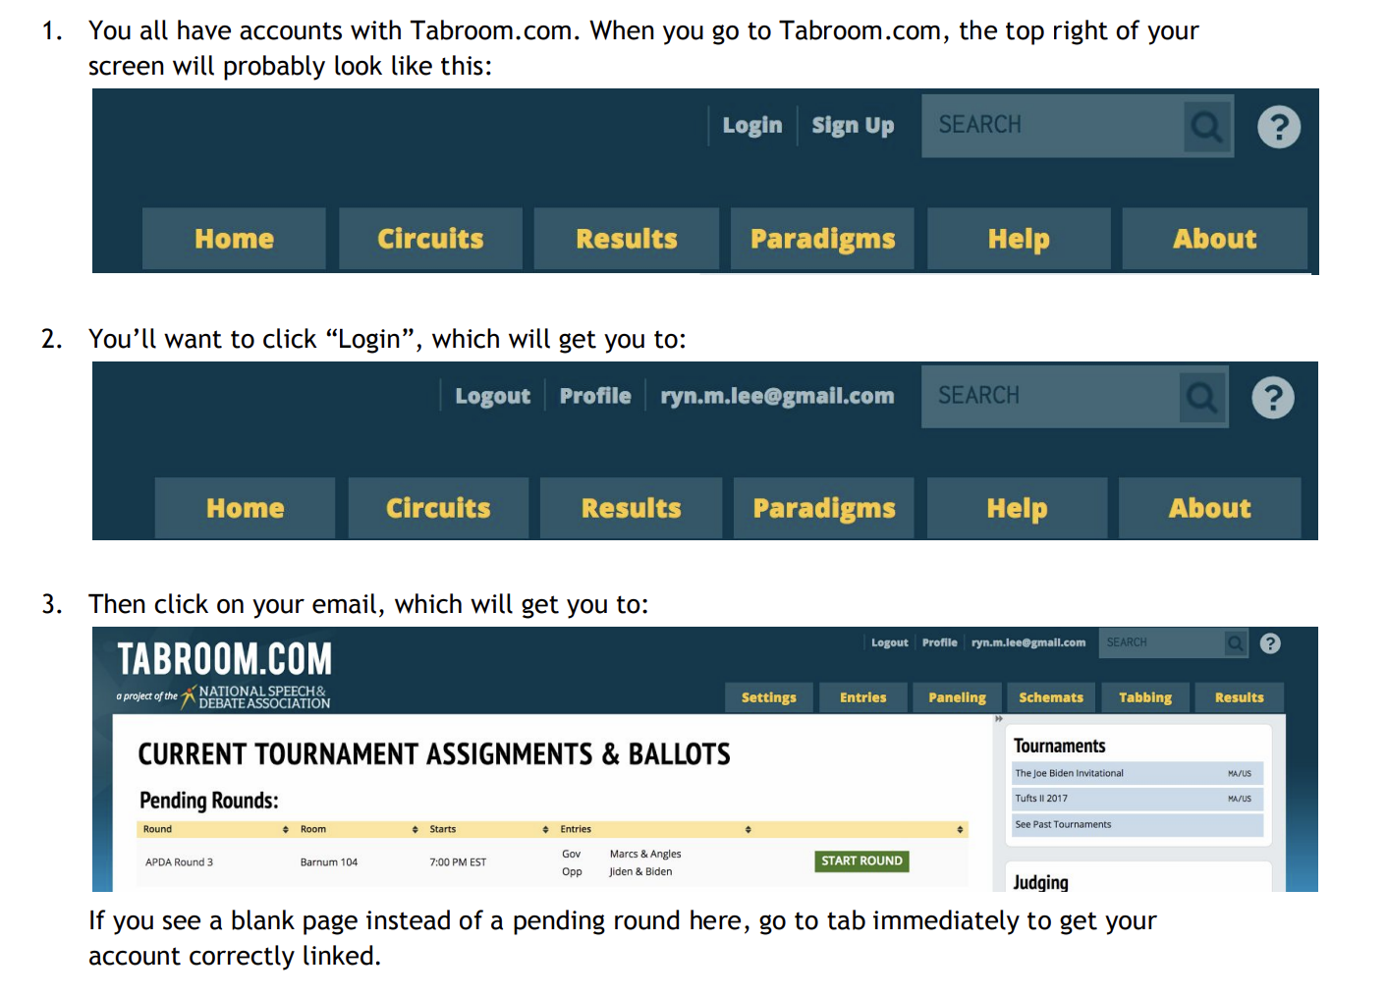

- Head to your room! Then make sure that the correct teams (A) and debaters (B) are in the room, and that both teams are aware of which side they are debating.
- Hit “Start Round”
- There is a feedback tab for each team, leave team/speaker specific feedback there as the round progresses.
- At the end of the round
  - Assign speaker points for each student in the debate round
  - Write your Reason for Decision and any additional comments
  - Choose the winner and submit your ballot

NAVIGATING TOURNAMENTS

Tournaments are an essential part of debate and the debate community. They are where debaters test out what they have learned, compete against debaters from other schools for team and individual awards, and receive feedback from judges. They are also where our entire community comes together to celebrate debate and support students.
You will have some down time in between submitting your ballot and the next debate round. Feel free to use this time to get some food, chat with other judges and coaches, but please do not leave the school without alerting the tournament director.

Judge Responsibilities, Summarized
Judges have specific and important responsibilities each round. Please make sure that you are completing each task in a timely manner to keep the tournament running on time. If you have any questions about any of these tasks, please speak with a tournament staff member.
Before the Round | During the Round | After the Round
- Check your email/tabroom account for your ballot  - Go to the room indicated on your ballot  - Confirm the teams in the room | - Keep time  - Listen actively  - Take notes | - Share verbal feedback  - Determine a winner  - Write a reason for your decision  - Assign speaker points and rank  - Submit your ballot via tabroom

Common Issues & Asking for Help
Tournaments are large events with many moving parts, and it’s not uncommon for some judges to encounter minor issues with their rooms or assigned rounds. For example, you might find that the door to your debate room is locked, that a team is late or doesn’t arrive to your assigned round, or that a team or debater is present in the debate room who isn’t listed on your ballot.
If these or any other non-emergency issues arise during your round, please text or call the tournament director, which will be written at the top of your ballot‬. Please include your last name and room number, and allow up to 10 minutes for a tournament staff member to come help. In case of a medical or other emergency, please call 911.
If you have any other questions or issues throughout the day, please feel welcome to ask a tournament staff member.

DOs AND DON’Ts FOR JUDGES

DO
- Listen attentively and with an open mind. Take notes.
- Keep track of time and give warning when there is one minute of speech time left.
- Leave biases and personal opinions out of your decision.
- Write legibly on the ballot.
"This activity and this league are meant to uplift youth thinking and youth voice. At the end of the day, debaters are walking away with a better understanding of what is going on in the world and a better understanding of how they can express themselves, using their voices.”

- Davian, Boston Latin Academy Class of 2017
- Offer encouragement during verbal feedback.
- Come back! Debate is an activity that takes time and practice to learn, and it’s okay to not understand everything right away. With time and experience, you will become a more confident judge.
DON’T
- Say who won
- Interrupt a speech or cross-ex (except to ask debaters to speak louder or more slowly)
- Use your phone except as a timer
- Vote or give feedback based on appearance, pronunciation, accent, or reading fluency
- Feel pressure to make the “right choice.” Students benefit from a diverse judge pool, and we value different decisions from different judges. Relax and try your best!

Thank you for your service!
Debate is not possible without volunteers like you.

DEBATE GLOSSARY

Debate Structure
Affirmative: The team in a debate which supports the resolution by proposing and defending a plan, usually a policy change, that improves upon the status quo.
Burden of proof: 1) The requirement that sufficient evidence or reasoning to prove an argument be presented 2) the requirement that the affirmative prove the stock issues.
Card (evidence card): A quotation from an expert that supports an argument. A card is also referred to as a “piece of evidence.”
Constructives: The first four individual speeches of the debate in which both sides build their arguments with evidence. Each of these speeches is immediately followed by a cross-examination of the speaker.
Cross-examination: A period which follows each of the constructive speeches in which a member of the opposing team directly questions the most recent speaker.
Closed Cross-Examination: A period in which only the most recent speaker is questioned by only one member of the opposing team.
Open Cross-Examination: A period in which both members of the team that most recently spoke are questioned by both members of the opposing team.
Low-point win: A win that occurs when the winning team has fewer overall speaking points.
Negative: The team in a debate which defends the status quo.
Plan: The Affirmative team’s specific proposal to create the change called for by the resolution.
Rebuttal: Any of the last four speeches in a debate. During rebuttals, new arguments are usually not allowed. Debaters should weigh the impacts of arguments previously introduced.
Role of the judge:
Prep time: The time allotted to each team for getting ready for their speeches once the debate has begun. This may be taken before any speech.
Maverick: A debater who is the only speaker for their team and who plays both speaking roles.
Debate Techniques & Strategies
Clash: Direct response to arguments made by the opposition.
Extending an argument: Bringing an argument up again in speeches after which they were initially presented. This sometimes involves reading new evidence to further explain or support the initial argument. Arguments that are not extended are considered “dropped” and are not supposed to be considered by the judge when deciding the round.
Roadmap: A short overview of arguments that a debater will make in their upcoming speech, this happens before the speech time begins.
Signposting: A clear indication of the argument that is immediately going to follow; this occurs during the speech itself.
Spreading: A debate strategy in which a speaker argues many points about a large number of arguments or topics at one time. Spreading is often confused with speed-reading, which is a technique that many debaters use in order to spread.

DEBATE GLOSSARY

Types of Arguments
Counterplan (CP): An alternative plan proposed by the Negative team that would solve the problem identified by the Affirmative in a different or more effective way.
Disadvantage (DA): An undesirable effect of a plan. A DA must explain how the plan is related to the undesirable effect (link), that the plan is key to the undesirable effect (uniqueness), and that the plan will ultimately make the world worse than before (impact).
Harms: Specific problems that are caused by and inherent to the status quo (see “Stock Issues”)
Impacts: The outcomes of scenarios posed in arguments throughout the debate, impacts should be analyzed on magnitude affected, risk of occurrence, and timeframe of occurrence (see “Disadvantage”)
Inherency: The reason that the status quo is unable to solve the harms (see “Stock Issues”)
Link: A logical connection from one concept or event to another (see “Disadvantage”).
On-Case: Arguments that directly respond to the Affirmative’s case. These usually include harms, inherency, and solvency.
Off-Case: Arguments that are brought up by the Negative that identify problems associated with the Affirmative’s plan, but aren’t mentioned by the Affirmative. These usually include disadvantages, counterplans, topicality,
Policy-making: A philosophy that debate rounds should be evaluated from the perspective of pseudo-legislators weighing the advantages and disadvantages of two conflicting policy systems. Judges generally assume this role unless debaters convince them otherwise.
Solvency: How the Affirmative solves the central dilemma (see “Stock Issues”)
Stock Issues: The key issues that usually make up the Affirmative’s main argument. These usually include harms, inherency, solvency, and topicality.
Topicality: Whether or not the Plan addresses the resolution as worded (see “Stock Issues”)
Uniqueness: An argument that explains how a plan is directly and significantly related to an undesirable effect (disadvantage).

